**Transmission advantage of SARS-CoV2 variants of concern in Belgium**

*Tom Wenseleers, 10th of May 2021*

To estimate the difference in growth rate (per day) between the variants of concern 501Y.V2 (B.1.351, South African variant) and 501Y.V3 (P.1, Brazilian variant) against that of 501Y.V1 (B.1.1.7, Kent or UK variant) we fitted a multinomial model to the baseline surveillance sequencing variant counts (aggregated by week) given in the weekly Sciensano report of the 8th of May 2021 (Fig. 1). This model was fit using the *multinom* function in the *nnet* R package and used a 2 degree of freedom natural cubic spline in function of sample collection date. Subsequently, the differences (contrasts) in growth rate (Δr) among the different variants evaluated today (on the 5th of May 2021) were calculated using the *emtrends* function in the *emmeans* R package, using a Tukey correcting for multiple testing (for details on methodology see Davies *et al. Science* 2021). From these growth rate contrasts, the relative transmission advantage was calculated as the exponent of the product of these growth rate differences Δr and the generation time, which we set here at 4.7 days (Nishiura *et al.* 2020) (see Davies *et al. Science* 2021).

The resulting estimates for the growth rate contrasts (per day) among the different variants of concern are given in Table 1. Compared to the UK variant 501Y.V1, The South African variant 501Y.V2 is currently decreasing in abundance relative to 501Y.V1 (resulting in a signfiicantly negative growth rate contrast of -4.6% per day, [-5.9%,-3.4%] 95% CLs). By contrast, the Brazilian variant 501Y.V3 has a small but significant growth rate benefit of 1.5% per day [0.3%,2.6%] 95% CLs compared to the UK variant 501Y.V1, which corresponds with a 7% transmission advantage ([1%-13%] 95% CLs). From this multinomial fit, 501Y.V1, 501Y.V2 and 501Y.V3 are estimated to make up 87% [84-90%], 0.6% [0.3-0.9%] and 10% [7-13%] of all lab diagnoses today (on the 10th of May 2021).

**Table 1.** Estimated growth rate contrasts (differences in growth rate per day) among different pairs of SARS-CoV2 variants of concern as well as the wild type (here defined as all other lineages) and corresponding transmission advantages, evaluated today (10th of May 2021).

|  |  |  |  |
| --- | --- | --- | --- |
| Comparison | Growth rate contrast Δr [95% CLs] (per day) | Transmission advantage (fold difference) | *p* value |
| 501Y.V1 – wild type | 0.033 [0.026,0.40] | X 1.16 [1.13,1.21] | < 0.0001 |
| 501Y.V2 – wild type | -0.013 [-0.026,0.0003] | X 0.94 [0.88,1.00] | 0.06 |
| 501Y.V3 – wild type | 0.048 [0.035,0.061] | X 1.25 [1.18,1.33] | < 0.0001 |
| 501Y.V2 – 501Y.V1 | -0.046 [-0.059,-0.034] | X 0.80 [0.76,0.85] | < 0.0001 |
| 501Y.V3 – 501Y.V1 | 0.015 [0.003,0.026] | X 1.07 [1.01,1.13] | 0.006 |
| 501Y.V3 – 501Y.V2 | 0.061 [0.044,0.077] | X 1.33 [1.23,1.44] | < 0.0001 |

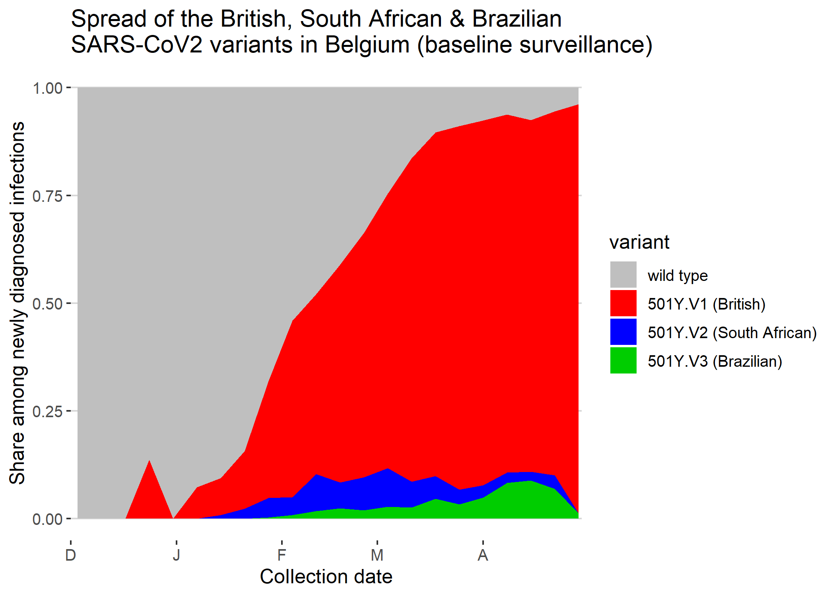

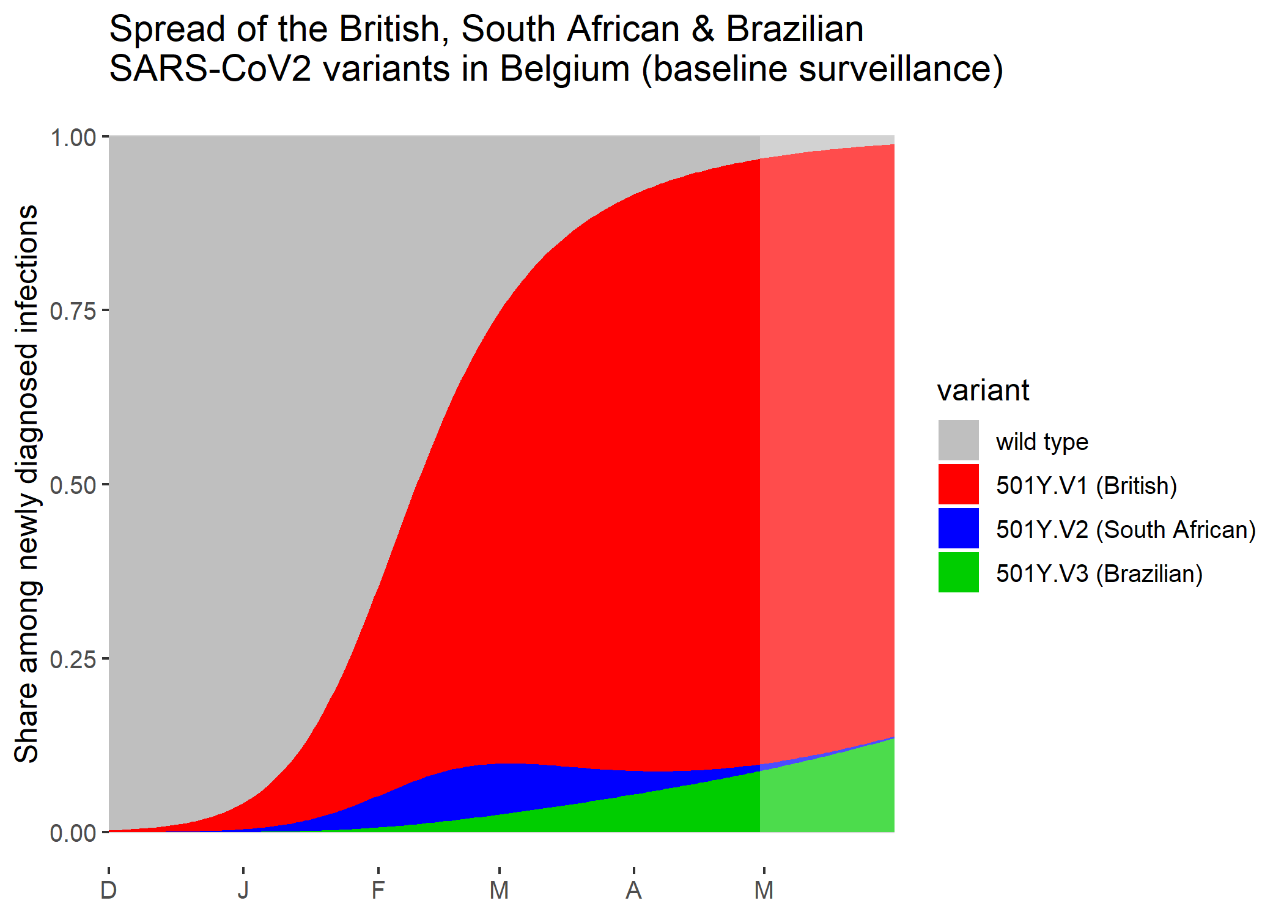

**Fig. 1.** Share of the 3 VOCs 501Y.V1, 501Y.V2 and 501Y.V3 out of all genomes sequenced as part of baseline surveillance testing (excluding individuals with a known travel history and surge testing). Top: raw data. Bottom: multinomial fit (using a model with a 2 degree of freedom natural cubic spline in function of collection date) to the share of the 3 VOCs (shaded bands are 95% confidence intervals).

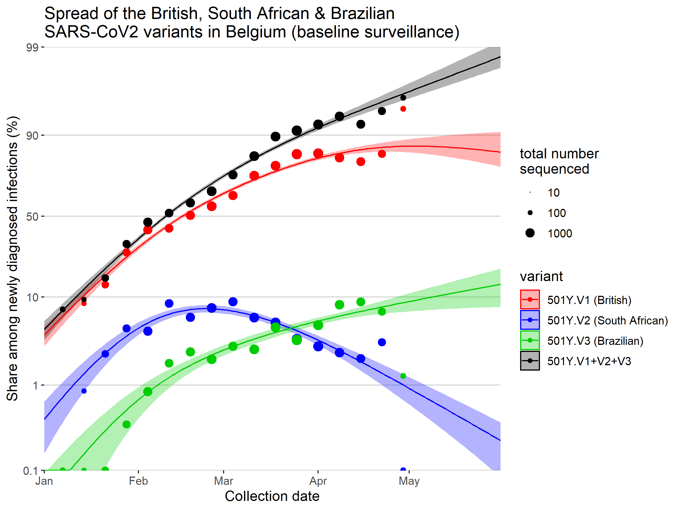

**Fig. 3.** Multinomial fit (using a model with a 2 degree of freedom natural cubic spline in function of collection date) to the share of the 3 VOCs 501Y.V1, 501Y.V2 and 501Y.V3 shown on a logit Y scale (shaded bands are 95% confidence intervals).